**LAB 4 TASK**

**ERD Diagram of Online Book Shop**

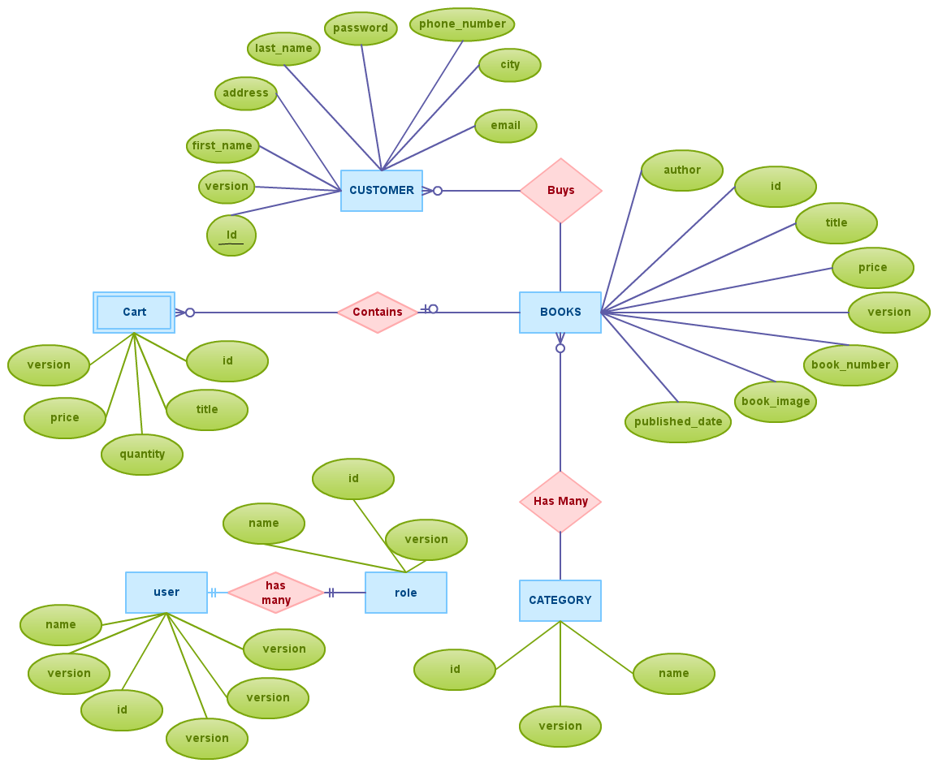

**DFD Diagram of Online Book Shop**

